**Appendix S1**

**Supporting Information for**

***Scaling of metabolism and maximum consumption with temperature and body size within species of fish***

Max Lindmarka,1, Jan Ohlbergerb, Anna Gårdmarkc

a Swedish University of Agricultural Sciences, Department of Aquatic Resources, Institute of Coastal Research, Skolgatan 6, Öregrund 742 42, Sweden

b School of Aquatic and Fishery Sciences (SAFS), University of Washington, Box 355020, Seattle, WA 98195-5020, USA

c Swedish University of Agricultural Sciences, Department of Aquatic Resources, Skolgatan 6, SE-742 42 Öregrund, Sweden

1Author to whom correspondence should be addressed. Current address:

Max Lindmark, Swedish University of Agricultural Sciences, Department of Aquatic Resources, Institute of Coastal Research, Skolgatan 6, Öregrund 742 42, Sweden, Tel.: +46(0)104784137, email: [max.lindmark@slu.se](mailto:max.lindmark@slu.se)

Contents

Literature search 3

*Growth rates & optimum temperature for growth over size* 3

*Metabolic rate* 4

*Maximum consumption rate* 4

Selection process and criteria 5

*Growth data* 5

*Metabolic and consumption rate* 6

Data acquisition 6

Data explanation 7

Data exploration 8

*Growth rate* 8

*Metabolic & maximum consumption rate* 10

Supplementary analysis 16

*Optimum growth temperature* 16

*Growth rate* 17

*Metabolic rate* 20

*Maximum consumption rate* 23

Bibliography 27

# Literature search

Prior to starting the actual literature review, we conducted several test-searches with alternative search-strings on Web of Science Core Collection, basic search. This was done in order to find a manageable number of papers to review and to have a reasonable ratio article titles that passed the first screening, given our pre-defined criteria for when to choose a study. As we suspected that relatively few studies would have considered both size- and temperature treatments, our goal was to get an as extensive as possible list of studies. Therefore, we also evaluated papers cited by papers in the literature list, and from published review-type papers and reviews of applications of bioenergetics models such as the Wisconsin model (Deslauriers *et al.* 2017).

## *Growth rates & optimum temperature for growth over body mass*

Growth rates were taken from data found in the literature search for optimum growth temperatures. We choose the following search strings for optimum growth rate experiments:

*TOPIC:* *(growth) AND TOPIC: (mass OR weight OR size) AND TOPIC: (temperature*) AND TOPIC: (optimum)*

This resulted in 3313 articles (search date: 2019.03.22). We then also applied additional filters on subject (Web of Science Categories). These were: ‘*fisheries’, ‘marine freshwater biology’, ‘ecology’, ‘zoology’, ‘biology’, ‘limnology’, ‘physiology’*. This reduced the number of studies to 566.

To find papers using either growth optimal or -optima, we also did the following search:

*TOPIC:* *(growth) AND TOPIC: (mass OR weight OR size) AND TOPIC: (temperature*) AND TOPIC: (optim*)*

This resulted in 3747 articles (search date: 2019.08.05). We then also applied additional filters on subject (Web of Science Categories). These were: *‘marine freshwater biology’,* ‘*fisheries’, ‘ecology’, ‘zoology’, ‘biology’, ‘limnology’, ‘physiology’*. This reduced the number of studies to 893, from which we removed the studies already found in the first search for growth rates.

## 

## ). The values are for most species derived from quadratic models in the original papers ($n=x$), but in some cases taken to be temperature where growth is maximized from a unimodal curve ($n=y$).

## *Metabolic rate*

We choose the following search strings for metabolic rate experiments:

*TOPIC: (metabolism OR "oxygen-consumption" OR "oxygen consumption") AND TOPIC: (mass OR weight OR size) AND TOPIC: (temperature*)*

This resulted in 8405 articles (search date: 2019.06.06). We then also applied additional filters on subject (Web of Science Categories). These were: ‘*zoology’, ‘physiology’, ‘marine freshwater biology’, ‘ecology’, ‘fisheries’ and ‘biology’.* This reduced the number of studies to 3458.

## *Maximum consumption rate*

We choose the following search strings for maximum consumption rate experiments:

*TOPIC:* *(consumption or feeding$rate or food$intake or bio$energ* or ingestion or food-intake) AND TOPIC: (mass or weight or size) AND TOPIC: (temperature*).*

This resulted in 15259 articles (search date: 2018.12.18). We then also applied additional filters on subject (Web of Science Categories). These were: ‘*marine freshwater biology’, ‘fisheries’, ‘zoology’, ‘physiology’, ‘ecology’, ‘biology’, ‘limnology’, ‘evolutionary biology’,* which reduced the number of studies to 3449.

However, due to a typo and misunderstanding of search syntax, we had to make a second search:

*TOPIC:* *(feeding-rate or bio-energ*) AND TOPIC:(mass or weight or size) AND TOPIC:(temperature*)*

This yielded 431 additional titles after filtering the following categories: ‘*marine freshwater biology’, ‘fisheries’, ‘zoology’, ‘physiology’, ‘ecology’, ‘biology’, ‘limnology’, ‘evolutionary biology’.*

# Selection process and criteria

We filtered out articles at three levels of the search: title, abstract and full paper. Appendix SX contains lists of paper titles at each of these steps in the filtering process. We also used studies that did not appear in the literature search but that we found by following cited literature in papers to the original source. Such studies are indicated in the data set as an explanation for why they do not appear in Appendix SX (see ‘*Data explanation*’, this document). We manually removed studies based on titles if it was clear that it did not fulfill all of the following conditions: (1) experimental study, (2) fish as study organism in life stages older than larval (3) replicates across both size and temperature. After titles we evaluated abstracts and then the whole paper using the same criteria. Further details on selection criteria specific to each rate are presented below.

## *Growth data*

In the search for growth rate data, we removed studies at the abstract and whole-paper stage from which we could not extract (4) growth rates, (5) a single controlled temperature for each growth trial and (6) a defined size class. In addition, we ensured that no other treatment (e.g. food limitation) confounded the response variable and thus only used data from experiments with food supply corresponding to satiation. It is important to control for feeding rations as it affects the temperature optimum for growth (Brett *et al.* 1969). This was achieved in different ways in the different experimental studies, but normally involves excess feeding rations once or several times per day. The key description we looked for in the study was that food should not be limiting or “reduced” rations. In the case growth was length-based, we converted them to mass using weight-length-relationships from FishBase (Froese *et al.* 2014; Froese & Pauly 2016). In cases where we found more than one study for the same species, we selected the study with most size-classes and largest size-range if more than one study had equal numbers of size-groups. While this reduces the number of data points, it avoids additional observation error due to different experimental setups and experimenters. We compiled two separate data sets: (1) raw growth rates (growth_data.xlsx) and (2) temperature at optimum growth (growth_data_Topt.xlsx), where we defined optimum temperature for growth as fitted optimum temperature (in the original study) or, in a few cases, as temperature where the highest growth rate of a unimodal growth-temperature relationship was achieved in cases where optimum temperature was estimate by the authors. All data were extracted from tables, or figures using Web Plot Digitizer (Rohatgi 2012).

## *Metabolic and consumption rate*

For metabolic- and consumption rate, articles where filtered out at the abstract and whole-paper stage if (4) the original reference could not be identified and evaluated, (5) it was a generic parameter-value based on literature rather than experimentally measured, (6) multiple rates measured at multiple temperatures were pooled prior to estimating the size-dependence of the rate, or if (7) units were normalized using a prior defined scaling relationships. In addition, for consumption we excluded studies if (8a) feeding was not ad-libitum (as with the growth data, definitions of ad-libitum may differ between studies – the key for our purpose is that rations should lead to satiation and not be limiting). For metabolic rate, we additionally excluded studies or if (8b) it was not standard/routine/resting metabolic rate or (9) there was no acclimation.

# Data acquisition

When treatments where conducted in the experiment, we extracted data from the control-scenario.

Here I will talk about:

* Unit standardization (in more detail than I do in the ms)
* Additional data in the data sets (how we got them and what we did we when didn’t, e.g. temperature data, body mass data).

# Data explanation

Here I will put all the columns in my data in a table like below and explain in words what all columns mean.

Table 1 EXAMPLE: Explanation of metabolic rate, maximum consumption and growth data

|  |  |
| --- | --- |
| Column | Explanation |
| e.g. temp_mid_fishbase | If no info, then used something else |
|  |  |
|  |  |
|  |  |
|  |  |
|  |  |
|  |  |

# Data exploration

Here I will put figures describing the data. Some examples are there, but more can come and maybe some of them can be combined

## *Growth rate*

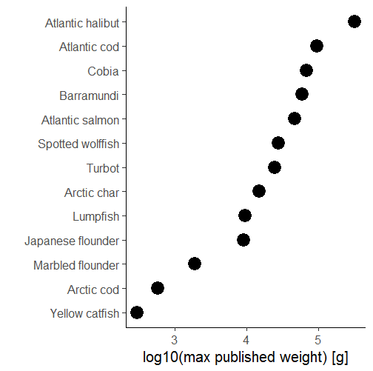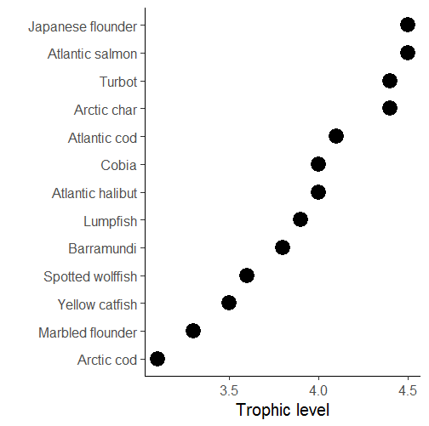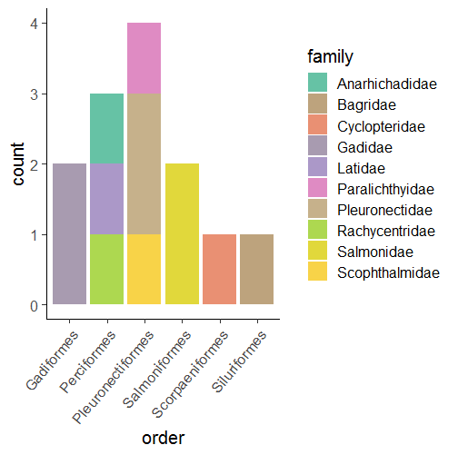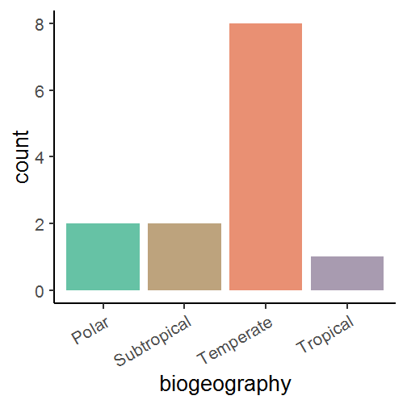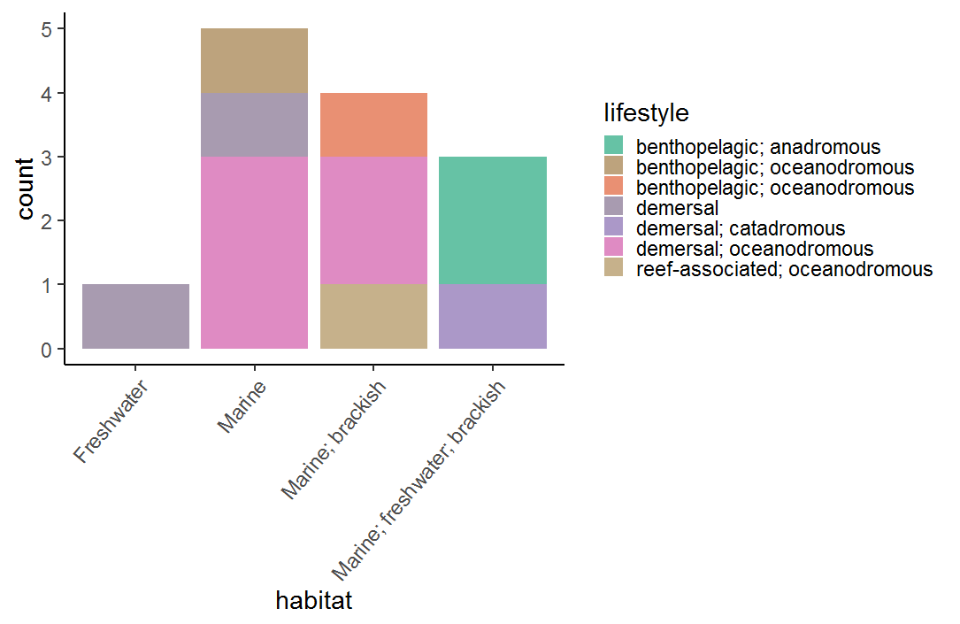

**A**

**B**

**C**

**D**

**E**

Fig. S1. Summary characteristics of data: A) Trophic level, B) Log10 maximum published weight (Fishbase), C) Biogeography, D) Taxonomic grouping, and E) Lifestyle, of species included in the final data set.

Fig. S2. Experimental temperatures (orange) compared to median environmental temperature (green) for growth data.

## *Metabolic & maximum consumption rate*

Fig. S3. Taxonomic representation in metabolism and consumption data set.

Fig. S4. Biogeography and lifestyle of species in metabolism and consumption data set.

Fig. S5. Log10 of maximum published weight of species in metabolism and consumption data set

Fig. S6. Experimental temperatures (orange) compared to range and median environmental temperature (green) for metabolism and consumption data

Fig. S7. Distribution of relative body masses in metabolism and consumption data set.

Fig. S8. *Posterior distributions of the average intraspecific mass-scaling exponents and activation energies ($μ_{β_{1,2}}$, and for metabolism also the non-species varying interaction coefficient ($β_{3}$) for metabolic rate (top row) and maximum consumption rate (bottom row). Numbers in the top left corner corresponds to the posterior median. Note that the final model for maximum consumption rate did not include a mass-temperature interaction term. The scale is the same within parameters across rates for comparison (and note that the mass-temperature interaction is estimated and presented on an Arrhenius temperature scale, 1/kT).*

# Supplementary analysis

## *Optimum growth temperature*

Fig. S9. Posterior densities and trace plots for evaluation of chain convergence (by chain, indicated by color), for the highest-level parameters for model

Fig. S10. for model

Fig. S11. Model fit (mean and coefficient of variation) for $T_{opt}$ model. Vertical line corresponds to mean in data and histogram depicts each posterior mean. Numbers show probability of the posterior being larger or small than mean in data.

## *Growth rate*

Fig. S12. Posterior densities and trace plots for evaluation of chain convergence (by chain, indicated by color), for the highest-level parameters for the growth rate model at temperatures below optimum temperatures.

Fig. S13. for growth model.

Fig. S14. Model fit (mean and coefficient of variation) for model of growth at temperatures below temperature optima. Vertical line corresponds to mean in data and histogram depicts each posterior mean. Numbers show probability of the posterior being larger or small than mean in data.

## *Metabolic rate*

Fig. S15. Posterior densities and trace plots for evaluation of chain convergence (by chain, indicated by color), for the highest level parameters for the model of metabolic rate at temperatures below optimum temperatures.

Fig. S16. for metabolism model.

Fig. S17. Model fit (mean and coefficient of variation) for metabolism model. Vertical line corresponds to mean in data and histogram depicts each posterior mean. Numbers show probability of the posterior being larger or small than mean in data.

## *Maximum consumption rate*

Fig. S18. Posterior densities and trace plots for evaluation of chain convergence (by chain, indicated by color), for the highest-level parameters for the model of maximum consumption rate at temperatures below temperature optima.

Fig. S19. for consumption model.

Fig. S20. Model fit (mean and coefficient of variation) for consumption rate model. Vertical line corresponds to mean in data and histogram depicts each posterior mean. Numbers show probability of the posterior being larger or small than mean in data.

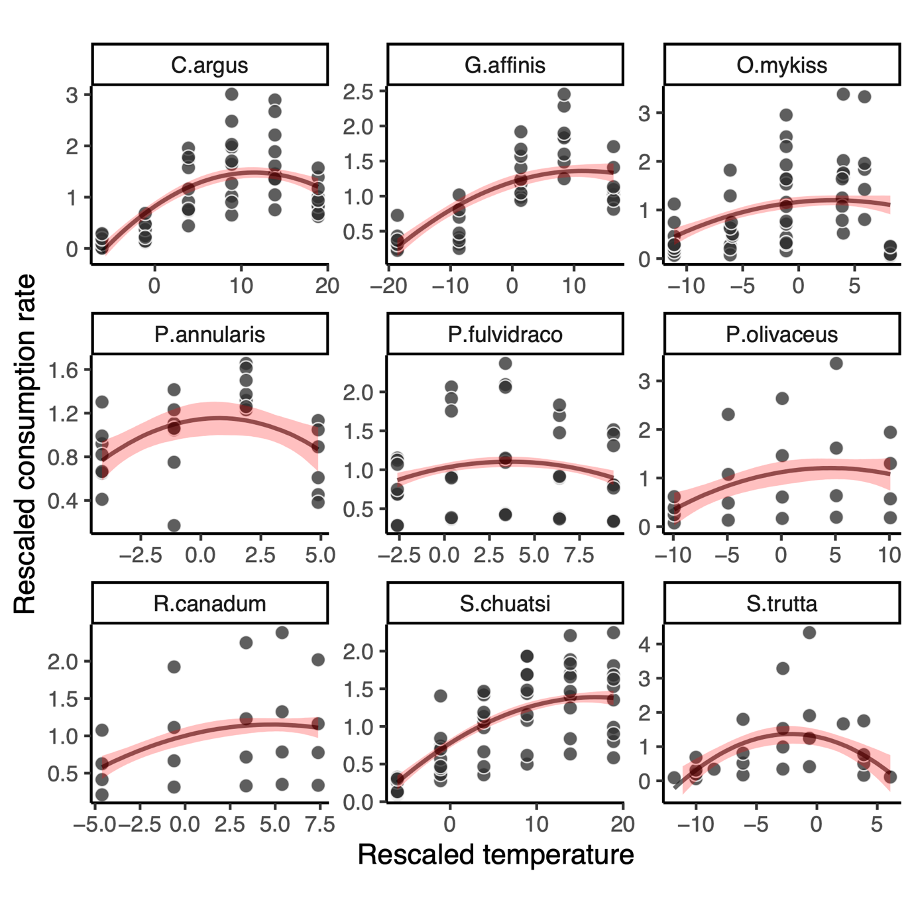

Fig. S21. Predictions (line), 80% credible interval (band) and data (points) from polynomial models of maximum consumption rate versus standardized temperature, fitted separately to each species.

Because they are fitted by species, I won’t show the validations…

# References

Brett, J.R., Shelbourn, J.E. & Shoop, C.T. (1969). Growth Rate and Body Composition of Fingerling Sockeye Salmon, Oncorhynchus nerka, in relation to Temperature and Ration Size. *J. Fish. Res. Bd. Can.*, 26, 2363–2394.

Deslauriers, D., Chipps, S.R., Breck, J.E., Rice, J.A. & Madenjian, C.P. (2017). Fish Bioenergetics 4.0: An R-Based Modeling Application. *Fisheries*, 42, 586–596.

Froese, R. & Pauly, D. (2016). *Editors. FishBase*. World Wide Web electronic publication. www.fishbase.org, (10/2016).

Froese, R., Thorson, J.T. & Reyes, R.B. (2014). A Bayesian approach for estimating length‐weight relationships in fishes. *Journal of Applied Ichthyology*, 30, 78–85.

Rohatgi, A. (2012). *WebPlotDigitalizer: HTML5 based online tool to extract numerical data from plot images. Version 4.1. [WWW document] URL https://automeris.io/WebPlotDigitizer (accessed on January 2019).*